**Project Development Phase**

**Model Performance Test**

|  |  |
| --- | --- |
| Date | 9 November 2023 |
| Team ID | [SI-GuidedProject-587104-1696656485](https://github.com/smartinternz02/SI-GuidedProject-587104-1696656485/tree/main) |
| Project Name | Android Application for Latest Headlines |
| Maximum Marks | 10 Marks |

**Model Performance Testing:**

Project team shall fill the following information in model performance testing template.

|  |  |  |  |
| --- | --- | --- | --- |
| **S.No.** | **Parameter** | **Values** | **Screenshot** |
|  | Metrics | App Launch Time- 60.97ms  Screen Render Time-2 Sec  [Code Quality-](https://github.com/smartinternz02/SI-GuidedProject-587104-1696656485/tree/main/Docs/Performance%20%26%20Final%20Submission%20Phase/Solution%20Performance) |  |
|  | Usage | App Size- 7.40MB  Customer Experience - |  |
|  | Performance | Error and Crash Rates- 1-2%  Database Query Performance- 99% |  |

1.1 App Launch Time-

app_time_stats: avg=60.97ms min=1.16ms max=725.20ms count=14



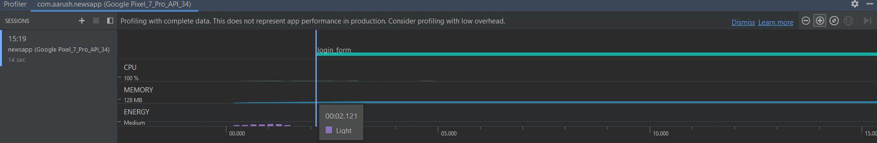1.2 Screen Render Time

1.3 Code Quality  
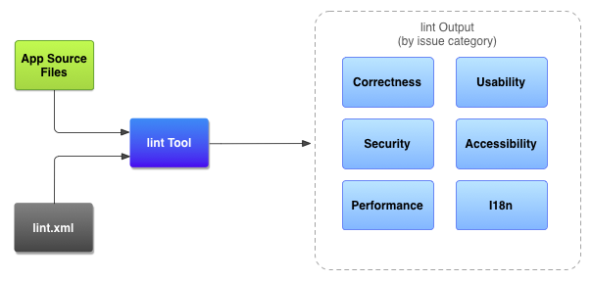

Link: [Code Quality](https://github.com/smartinternz02/SI-GuidedProject-587104-1696656485/tree/main/Docs/Performance%20%26%20Final%20Submission%20Phase/Solution%20Performance)

2.1 App Size

